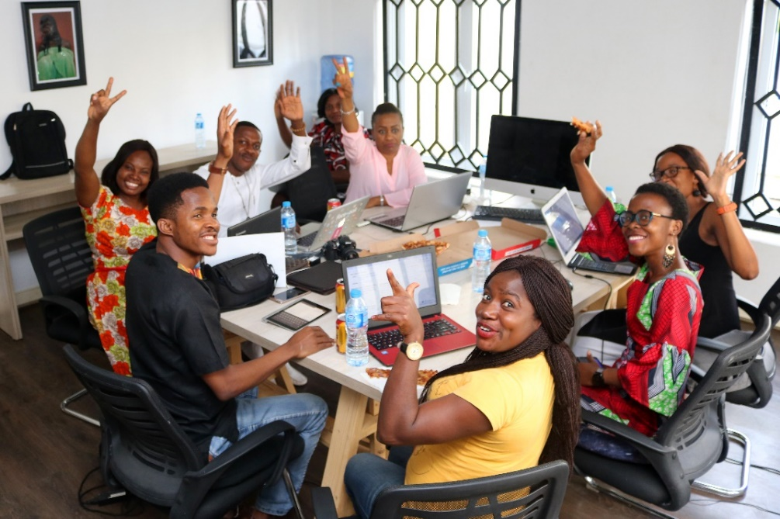

**Schedule:**

March 2nd-30th

Mon/Tue 12pm-3pm

**Location:**

406 Edmonton Street, 2nd floor

**Take home a**

**FREE desktop computer**

**at graduation!**

For clients with limited English (CLB 1-4)

and no/limited computer experience

Interpreters provided

# Altered Minds Inc. in partnership with Manitoba Islamic Association offers:

**Computers for Life**

**Basic Computer classes for beginners**

* Use the keyboard
* Send and receive emails
* Find info online and complete online forms

To register, please bring personal identification and immigration document to:

**ALTERED MINDS INC**

259 Portage Ave, Unit 400

Tel: 204-944-0133

Email: [computers@alteredminds.ca](mailto:computers@alteredminds.ca)

Website:

<https://alteredminds.ca/computer4life/>

* Translate between English and your language
* Make video calls to family and friends
* Use maps and Navigo to plan a trip
* Apply for jobs & services online
* Do online banking & shopping
* Learn about Internet safety

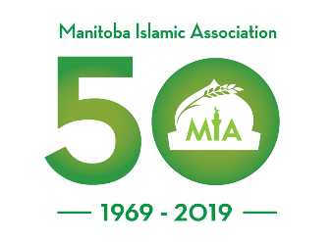

With funding from